# Work Breakdown Agreement Assignment 1

Kelvin:

UML Diagrams (Brief Copy)

Providing documentation of UML Diagram understanding

Sequence Diagrams (Brief Copy)

Proofreading of Sequence diagrams

Flowcharts

Github committing 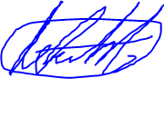

Matt:

Sequence Diagrams (Brief Copy)

Providing documentation of Sequence Diagram understanding

Proofreading of UML diagrams

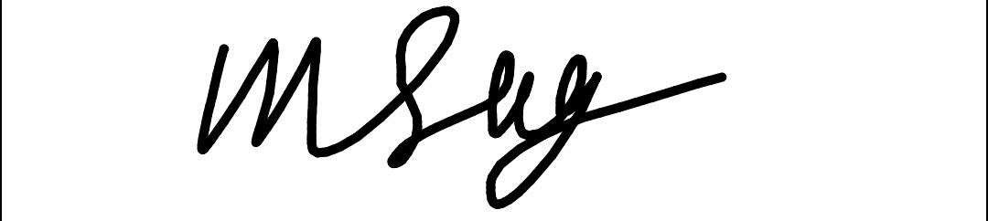Writing the WBA

Github committing

# Work Breakdown Agreement Assignment 2

Kelvin:

Check the classes

Help each other understand template code

Write documentation of Assignment 2

Github committing

Matt:

Apply classes to the Star Wars code

Help each other understand template code

Writing the WBA

Github committing